Q1. Use code “parallel/RankSortParallel.c” as example code to work out contents of textbook Appendix C to show that you know how to use the various performance debugging tools provided by the C\* environment. Submit screen captures organized into a Word file showing how you tried out the Appendix C performance debugging features on the sample code. This skill is valuable for your later projects.

Solution:

1. View function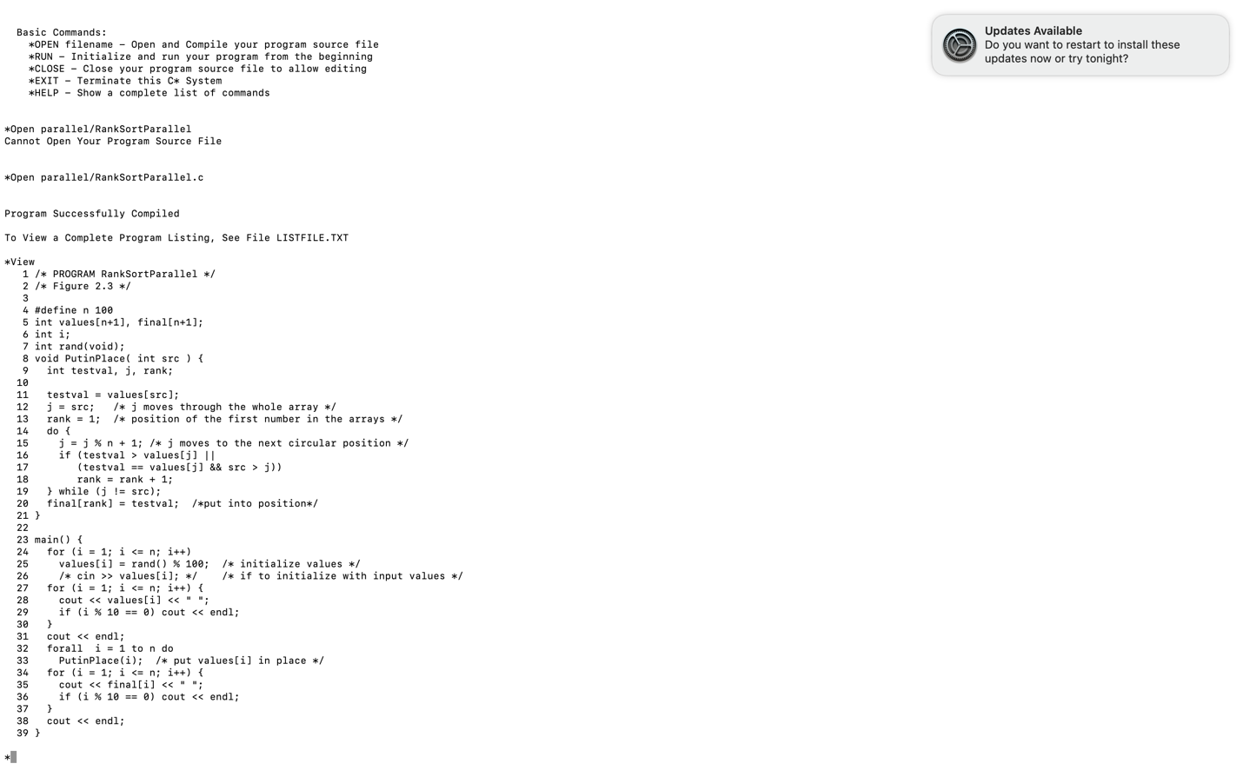
2. Break and Clear Break FunctionText

   Description automatically generated

1. Run and Continue Function Graphical user interface, text, application, email

   Description automatically generated
2. Write Function

1. Trace Function

1. StatusA picture containing letter

   Description automatically generated
2. Clear Trace

1. ResetText

   Description automatically generated with medium confidence